1. Software Architecture
System Architecture
The MediCare System is a web-based application that helps manage pregnant women, appointments, health monitoring, and family updates.
The system has three main parts:
Frontend:
The pages seen by the Admin, Doctor, Pregnant Woman, and Family Member.
Backend:
The PHP logic that processes actions, checks data, and controls access.
Database:
Stores users, pregnant women records, appointments, vitals, delivery status, and messages/updates.
How the system works
- Admin logs in from the Frontend.
- Login request goes to the Backend.
- Backend checks the Database for the email, password, and role.
- If correct, the Admin dashboard opens.
- Admin registers a new pregnant woman.
- Backend validates the entered information.
- Database stores the pregnant woman’s name, age, due date, last period, and assigned doctor.
- Doctor opens a patient record.
- Backend requests the patient’s data from the Database.
- Database returns pregnancy details, vitals, appointments, and risk status.
- Doctor updates vitals or marks the patient as high risk if needed.
- Pregnant Woman views her appointments and pregnancy status.
- Backend gets her personal data from the Database.
- Frontend displays the latest information.
- Family Member checks delivery/operation status.
- Frontend sends a status request to the Backend.
- Backend checks the Database for the latest status.
- Backend sends the result back to the Frontend.
- Family Member sees updated status, such as “Monitoring,” “High Risk,” or “Completed.”
- When delivery is completed, the Doctor/Admin updates the status.
- Backend saves the final status in the Database.
- The updated status becomes visible to the Pregnant Woman and Family Member.
2.Detailed design
Components Diagram
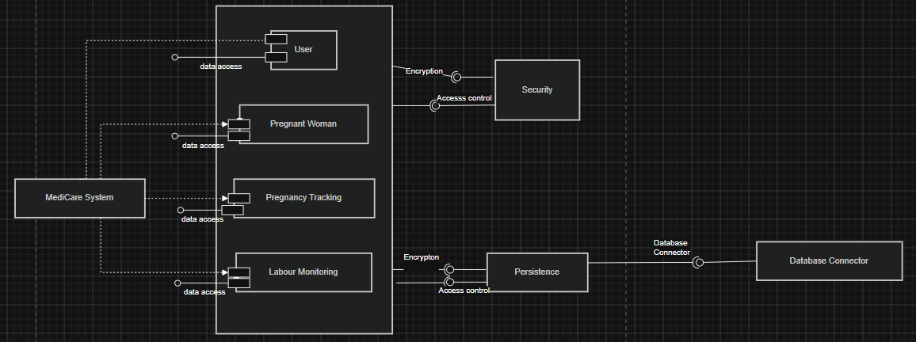
User
Handles user authentication and account management (login, registration, roles like admin or family).
Pregnant Woman
Stores patient information such as name, age, due date, and medical profile.
Pregnancy Tracking
Manages weekly pregnancy data like weight, symptoms, and notes.
Labour Monitoring
Tracks real-time labour data such as heart rate, dilation, and delivery status.
Data Access
Means each component can read and write data from the database.

2. Detailed Design Class Diagram
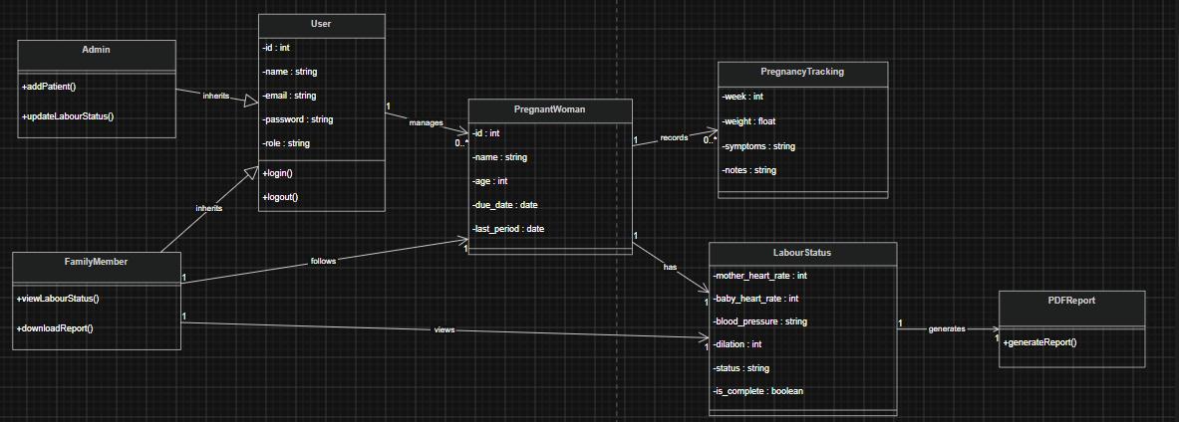
This class diagram represents a MediCare system where users (Admin and Family Members) interact with pregnant patients. Each pregnant woman is managed by a user, has multiple pregnancy tracking records, and one labour status during delivery. Family members can view the patient’s condition in real time, while the system generates a final report after labour.

Sequence diagram
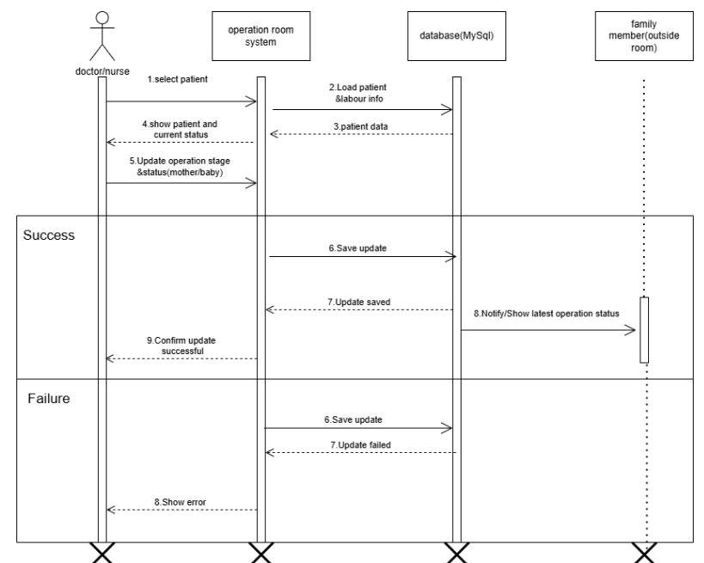

3. Modeling
Use Case Diagram

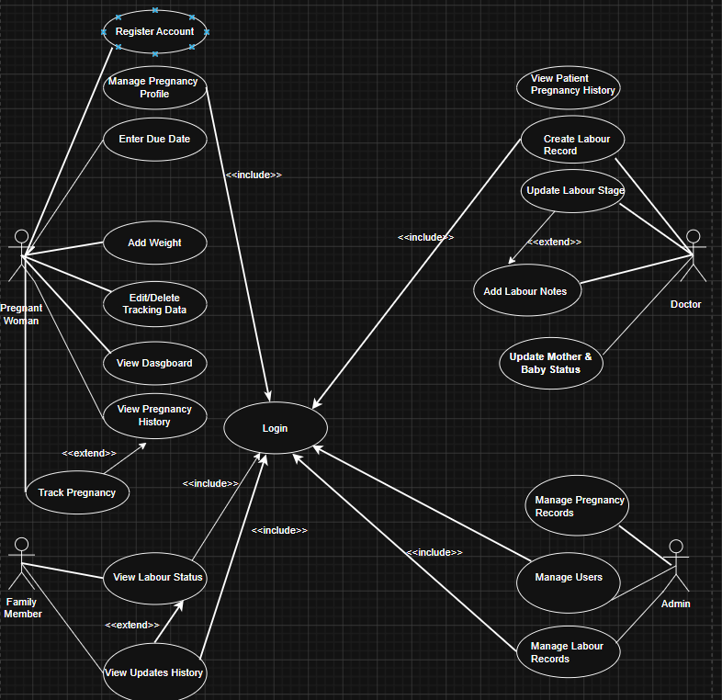

Activity Diagrams

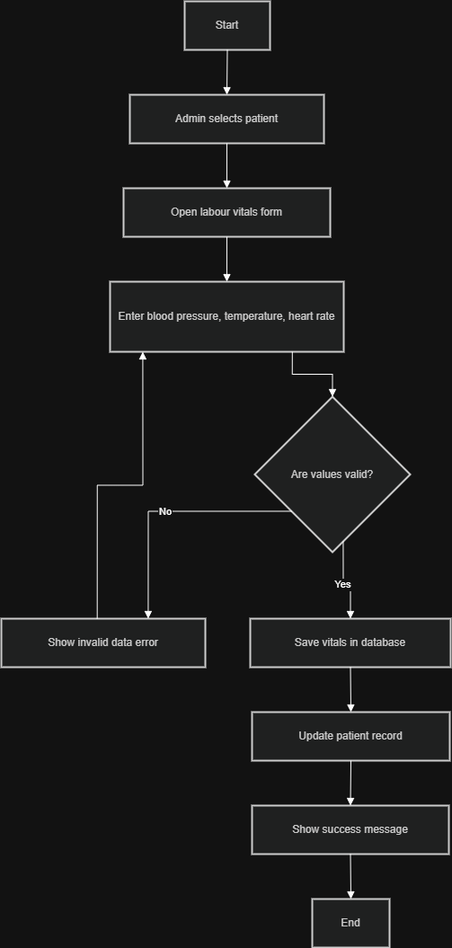

State Diagrams
